Fall Fitness Tips for Family and Friends
Fall is here, the leaves are changing, the temperature is dropping and the joy of being outdoors in Texas is felt from all regions. The change in season means a lot of activities and people excitedly prepping for upcoming events. Below are some tips on how we can keep active while enjoying the breezier climate and our busy social schedules:

Participate in a holiday or fun fall activity
Gather friends and family, a pair of comfy boots or sneakers, and walk around a corn maze or browse through the patches and select the most vibrant pumpkin. Enjoy the fresh weather while bonding with the family and create memories that will last forever.

Hit the trails or take a stroll
Take advantage of the nice weather and go for a walk at the park or a hike at the trails. You can also take part in a fitness challenge like joining a 5K run or joining a Walk Across Texas! (WAT!) program in your area. This year, Texas A&M AgriLife Extension Service is celebrating 25 years of WAT!, an eight-week program that encourages the start of regular physical activity.

Go to a farmers market
Explore what fruit and vegetables are in season and fill up on the season’s favorites such as apples, cabbage, cauliflower, kale, onions, spinach and of course, pumpkins. The farmers market is the perfect place to walk around and explore, while stocking up on produce at a budget-friendly price.

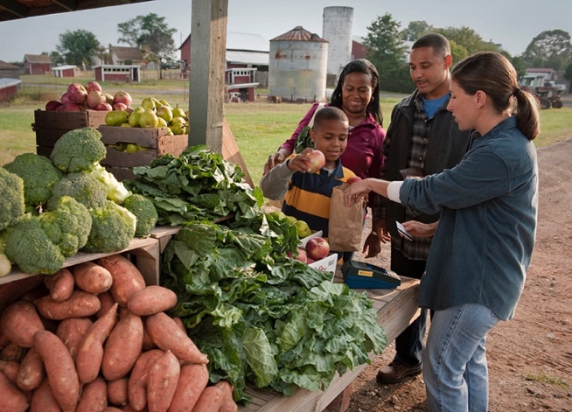

Rebrand your household chores
Need to walk the dog? Take a longer walk and admire the beautiful Texas sunset. Fall leaves piling? Rake and bag the leaves. This activity can raise your heartrate and checks one thing off your to-do list.

There are plenty of activities this month that can keep us active, engaged, and connected to our loved ones. Enjoy the sights, the weather, and the opportunity to shake up your routine and continue your good habits!

Written by Genesis Victoria Hernandez, Extension Agent - Better Living for Texans
Adapted From: https://www.nm.org/healthbeat/healthy-tips/fitness/family-fun-fitness-fall and https://www.pennmedicine.org/updates/blogs/health-and-wellness/2018/october/tips-to-stay-active-this-fall
Photo source: https://snaped.fns.usda.gov/photo-gallery/family-purchases-produce-farmers-market-vendor
Local Events

Recipe of the Month
Recipe and photo source: MyPlate Kitchen, https://www.myplate.gov/myplate-kitchen

Salad with Apples and Raisins

Enjoy this tasty, sweet fall salad with a savory and seasonal entrée. Use Granny Smith or your favorite kind of apples. Try leaving out the sugar for a tarter flavor.
Serves: 6

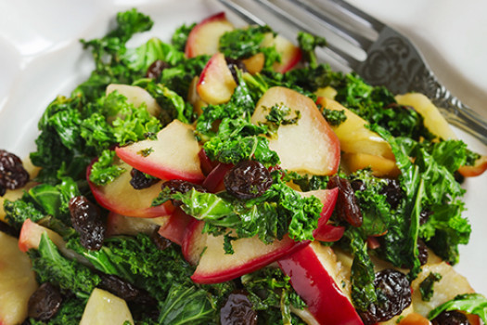
Ingredients:

10 | ounces washed baby spinach, kale, or other greens
2 | chopped apples
1 | cup raisins
¼ | cup canola oil
¼ | cup apple cider vinegar
¼ | cup sugar
¼ | teaspoon garlic powder

Directions:

1. Combine spinach, apples, and raisins.
2. Mix all dressing ingredients and pour over salad just prior to serving.

Nutrients Per Serving: 212 calories, 9 g total fat, 1 g saturated fat, 0 mg cholesterol, 29 mg sodium, 33 g carbohydrates, 2 g fiber, 26 g total sugar, 8 g added sugar, and 2 g protein

Total Cost per serving: $$$$

