2020 Baylor County Healthy Aging
Summary developed by Joy Self, County Extension Agent, Baylor County
Relevance
Memory education, fall management, and medication management for older adults have been identified as a need by the Baylor County Family & Community Health Committee. Adults age 65 and older represent approximately 12% of the population in Texas. The adults over age 85 are the fastest growing segment of the population within Texas and across the United States. Of the 3 million Texans that are over 65, only 5% of that number live in residential care facilities. Assessments show that many people over age 65 living in the community require substantial aid that is provided by family members.

While there are modifications in memory as people grow older, generally people can improve their memory with education and practice. Improving memory requires a belief that change is possible. Research has shown that older adults were less likely than younger adults to attribute memory function to controllable factors such as using effective strategies. While more than 80% of those over age 65 complain about their memory problems, only 15% take steps to remedy their forgetfulness. Those seniors who did make attributions to these factors demonstrated better performance than their peers who did not see memory as being under their control. Other research demonstrated that older adult memory performance can be improved through external and internal strategy training.

One out of three adults age 65 and older falls each year, but less than half talk to their healthcare providers about it. Among older adults (those 65 or older), falls are the leading cause of injury death. They are also the most common cause of nonfatal injuries and hospital admissions for trauma. Older adults can remain independent and reduce their chances of falling. Matter of Balance is an evidence-based falls management program for older adults that acknowledges the risk of falling but emphasizes practical coping strategies to reduce risk and fear.

Health information and services are often unfamiliar, complicated, and technical, even for people with higher levels of education. People with limited health literacy are less likely to use preventive services, such as vaccinations and cancer screenings; less likely to successfully control chronic conditions, such as hypertension and diabetes; and more likely to self-report poor health. Additional research links limited health literacy to misunderstanding instructions about prescription medication, medication errors and mortality. Health literacy is part of a person-centered care process, essential to the delivery of cost-effective, safe, and high-quality health services.
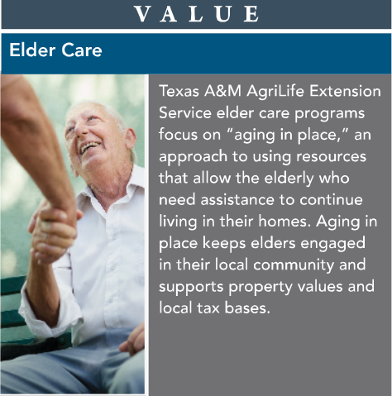
Response
The 2020 program year was unlike any other as Texas A&M AgriLife Extension Service along with other agencies, organizations, families and individuals responded to a different work, school and home environment due to the global response to the Coronavirus Disease 2019 (COVID19) pandemic. With its network across the state, Texas A&M AgriLife Extension Service was able to respond at the local, regional and state level with virtual educational efforts designed to reach individuals and families with resources and education to help them continue with aspects of their daily life related to health, safety, agriculture and youth development. Although our educational activities, outcomes and impacts may look different for 2020, we continue our efforts to help Texans better their lives.
Results
Master of Memory, Matter of Balance, and Healthy Literacy could not be implemented due to the Randal Wellness Center being closed where the programs have been administered. Preparations are underway to conduct the programs in the spring and summer of 2021.

Acknowledgements
Texas A&M AgriLife Extension Service in Baylor County would like to acknowledge the partnership of Randal Wellness Center and the Baylor County Family and Community Health Committee who assisted with planning and implementing these programs.

