2020 Baylor County-Better Living for Texas (BLT) Programs
In-depth Plan Summary
Joy Self, CEA-FCH
Relevance
The high occurrence of juvenile obesity in Texas is cause for concern since it is associated with negative health outcomes for children and their families. Schools are distinctively positioned to have a positive influence on children’s knowledge and behaviors associated with obesity. The home environment makes a crucial impact on a child’s consumption and activity behaviors. The greater the frequency of vegetable consumption and physical activity by parents, the greater the consumption of these nutrients and exercise by their children. With child obesity rates among low-income children in Texas ranging from 10% to over 20%, engaging schools and families in prevention efforts is critical. The U.S. Department of Agriculture Supplemental Nutrition Assistance Program (SNAP) has partnered with Texas A&M AgriLife Extension Service – Better Living for Texans (BLT). The partners provide participants with research-based information in a comfortable and friendly environment. Research suggests that SNAP recipients and other limited resource audiences consume diets that are not in agreement with current dietary recommendations, potentially increasing their risk for the development of chronic disease. Food insecurity, obesity, and lack of access to healthy foods are other issues that impact this audience and have strong potential to negatively impact health. In Baylor County, 543 recipients benefit from this valuable program.
Response
After reviewing the programs in the BLT curriculum, the Baylor County Family Community Health (FCH) Program Area Committee was enthusiastic that there are programs that provide research and evidence-based nutrition, health and wellness knowledge that empower individuals, families, and the Baylor County community to make positive changes for healthier lives. The committee supported the following programs that would address the concerns of nutrition, physical activity, and health at any age:
- Balancing Food & Play - A four week, 20-lesson program developed for youth (3rd graders) that addresses children's health issues through nutrition, physical activity, and family engagement. Lessons are based on the Texas Essential Knowledge and Skills (TEKS) and teach the importance of increasing physical activity, reducing screen time, increasing fruit and vegetable intake, and decreasing sweetened beverages.
- A Fresh Start To A Healthier You and Walk Across Texas (WAT) – The 2020 program year was unlike any other as Texas A&M AgriLife Extension Service along with other agencies, organizations, families and individuals responded to a different work, school and home environment due to the global response to the Coronavirus Disease 2019 (COVID19) pandemic. With its network across the state, Texas A&M AgriLife Extension Service was able to respond at the local, regional and state level with virtual educational efforts designed to reach individuals and families with resources and education to help them continue with aspects of their daily life related to health, safety, agriculture and youth development. Although our educational activities, outcomes and impacts may look different for 2020, we continue our efforts to help Texans better their lives.

Results
Balancing Food & Play – A total number of 46 third grade students completed the curriculum of Balancing Food & Play. The average age of the participating students was 9 years old. Participants provided pre and post surveys which were used for program evaluation. Astounding results were found from the ten following questions:
- A child your age should be physically active 60 minutes a day. Pre 35% Post 100%
- Children your age should have no more than 2 hours of screen time a day. Pre 17% Post 100%
- ½ your dinner plate should be vegetables or fruits/vegetables. Pre 37% Post 89%
- You got at least one hour of physical activity each day for the last 7 days. Pre 17% Post 32%
- Ate vegetables at least three times yesterday, not counting French fries. Pre 26% Post 61%
- A can of soda (not diet) has 10 teaspoons of sugar. Pre 28% Post 72%
- Ate fruit at least three times yesterday, not counting juice. Pre 30% Post 61%
- Did not drink more than one sweetened drink like soda. Pre 17% Post 72%
- On an average school day, you did not watch/play more than 2 hours a day. Pre 65% Post 94%
- In general, how would you say your health is good. Pre 43% Post 83%
Testimony from 3rd Grade Teacher, “Balancing Food & Play helped the students discover effective ways of how to eat healthy foods and exercise regularly.”

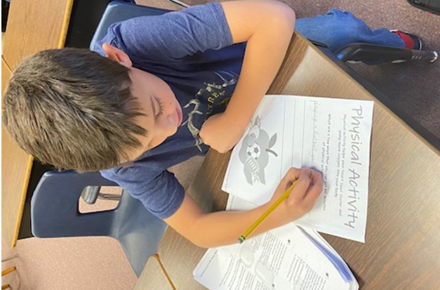
By conducting the Balancing Food & Play program, students increased their scores by +48% when comparing pre-survey results to post-survey.
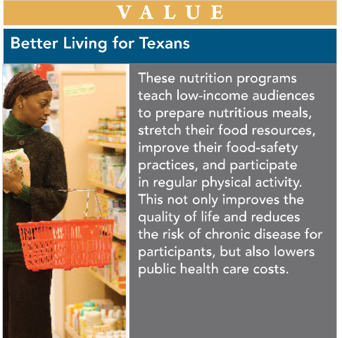
A Fresh Start To A Healthier You could not be implemented due to no face to face programs during the pandemic. Preparations are underway to conduct the programs in the spring of 2021.
Walk Across Texas was implemented at Seymour Elementary School. However, due to going to distance learning the teachers had a hard time implementing the information into the system so preparations are underway to conduct the programs in the spring of 2021.
Acknowledgments
Texas A&M AgriLife Extension Service in Baylor County would like to acknowledge the partnership of Seymour Elementary third grade teachers and principal and the Baylor County Family and Community Health Committee who assisted with planning and implementing this program.

Future Programming
As a result of the impact of these programs, the FCH Committee desires to continue to support and implement the BLT programs in the Baylor County community.

